QUESTION AND ANSWER ON CONTROL ARCHITECTURE

* Command shaping filter in the Setpoint generator block
* In the controller bloc, why is V_d added in that specific point,
* Feedforward , A_d
* Is the architecture design based on some “main” theoretical approach or document? Is there some video that explain all of this “architecture” control”?
* A page of a computer program

  Description automatically generated with medium confidenceA diagram of a machine

  Description automatically generated The reason why we do position and than attitude control is the same as in the Matlab videos? If not why are we doing this.
  + My take on this… is not. It’s completely different and I do not understand why we are talking about d

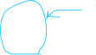

POSITION CONTROL

* A diagram of a computer process

  Description automatically generatedWhat each of this block means? Why are we doing position than velocity and than what’s “feedforward gravity control” Is a control approach to first control the position and than velocity? There is some document about this topic? I’ve never saw anything like this before.
  + –
* A screenshot of a computer

  Description automatically generatedWhy the saturation of -10 , + 10in the position controller? Is this the reason we have problem in our setpoint generation block where we try to test the control? (values to high crash the control).
  + .
* A diagram of a machine

  Description automatically generatedA diagram of a software processing process

  Description automatically generatedA diagram of a machine

  Description automatically generatedA screenshot of a computer

  Description automatically generatedExtract Setpoint for the attitude control … this is clearly a complete different approach from the matlab videos.

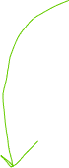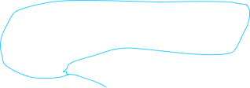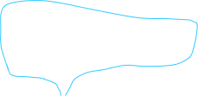

* A diagram of a computer

  Description automatically generatedI know that on one note you started writing the dynamic explanation, we should write it clearly in relation to our exact problem.



RICCARDO AGOSTINIS:

1. Feedforward gravity compensation block in the position controller:

Why is it g_vect added to the feedforward block with sign ‘-‘? Is it because the output signal from the feedforward gravity compensation is expressed in the ECI frame of reference, therefore you have to take into account that to compensate the gravity force you have to exert an upward force, therefore in the NED frame of reference it will be with signus ‘+’.

And why the compensation is g_vect and not ‘m * g_vect’

1. Saturation in the position controller block: why?
2. Delay and saturation in the plant:

Why is it modeled as a first order system? Does the motor behave so?

RISPOSTE:

Saturation of the total force: get data from datasheet on max thrust;

Model the motor as first order system, with bandwith (?)